CHAPTER SEVEN
RESISTANCE TO HEGEMONY WITHIN THE CORE: DOMESTIC POLITICS, TERRORISM, AND POLICY DIVERGENCE IN THE G7
THOMAS J. VOLGY, KRISTIN KANTHAK, DERRICK FRAZIER, AND ROBERT STEWART INGERSOLL
Our approach to the topic of challenges to American hegemony places them in a context focused on changes in hegemonic strength. We expect the nature, location, and salience of challenges to vary with the strength of the U.S. Declining U.S. structural strength will affect both American strategies of maintain the world order it desires and the nature of challenges from major allies and the institutions within which they work to maintain the status quo. In this sense we focus not on those in international politics that are dissatisfied with the status quo but on essentially status quo states in the hegemonic core. We do so since we believe that as U.S. hegemonic strength declines, America is likely to come to depend more on institutions and groups of states sharing its perspective and commitment to the status quo. When those relationships weaken, U.S. control over global affairs becomes more tenuous.
Perhaps more controversially we focus less on strategies to resist U.S. leadership and more on variation in policy cohesion between America and its key allies, that is, on policy divergence. It is almost a trivial and obvious but often ignored point that policy divergence is a critical condition for challenging hegemony. That is almost by definition true for dissatisfied states. For pro-status quo coalition partners, however, it is not all obvious that such policy dissension is or will be substantial. Further, there is often much less than full understanding of the roots of such policy dissension amoung the “satisfied” states. While such policy dissension can be overcome and challenges to hegemonic U.S. control minimized (even in the core), it is far more costly than when there is policy congruence. The possibility of major challenges to U.S. leadership in the core creates fundamental problems and especially so when U.S. leadership requires core support to supplement its capabilities. For these reasons our chapter focuses not on resistance strategies but on the critical condition (policy dissension) that gives rise to their use by others in the hegemonic core.
Finally, we focus not on individual states or on regions of evasion, modification, and resistance, but specifically on the G7 as a group, and particularly on variation in the G7’s aggregated level of policy cohesion. We do so because the G7 was established and institutionalized to supplement declining U.S. hegemonic capabilities, and as a group, the G7 has overwhelming economic, political, and military capabilities in the international system. For over a quarter century, spanning both the Cold War and post-Cold War eras, the G7 has played an important role in maintaining the U.S. centered international order. Whether it continues to do so may in no small measure depend on the extent that its members maintain a substantial degree of policy cohesion regarding critical international problems and the strategies for dealng with them.
The sections that follow discuss hegemonic strength, the role of the G7 in international politics, and the historical variation in policy congruence between G7 members. We then measure levels of policy cohesion over time, and apply a domestic politics framework to assess changes in it. The results highlight the difficulties G7 states face in creating a common perspective on new systemic disturbances, such as international terrorism, and we suggest that international terrorism is likely to increase both policy disagreements and G6 challenges to U.S. hegemonic initiatives.

Hegemonic Strength
Hegemony (or global leadership) requires much from a leading state, including preponderant strength, along with the motivation/desire, and competence to use it in developing rules and norms for the international system. Strength alone is clearly not enough, nor is it necessarily accompanied by motivation or competence. Nevertheless, global leadership becomes a dangerous illusion in the minds of foreign policy makers without sufficient strength to impose a roadmap on global events, and to enforce the rules and norms required for implementing it.
Much of the neorealist literature assumes that sufficient amounts of strength will exist among the great powers in the system to allow them to fashion a global architecture. According to these assumptions changes in the distribution of strength between great powers determine changes in the shape of the system (e.g., unipolar/ hegemonic, bipolar, multipolar). We view it an empirical question as to whether or not sufficient strength exists to fashion global architecture and to enforce the norms accompanying it, and especially with respect to hegemony or global leadership.
What type of strength is needed? Susan Strange (1989) argued forcefully that global leadership requires two types of strength: relational and structural. Relational strength refers to the capabilities of a hegemon or a global leader vis-à-vis other actors in the system, and its ability to get some groupings of others, by persuasion or coercion, to do what they would not otherwise do.
Structural strength for Strange reflected a different dimension of capabilities, referring to the capacity of a hegemon to create essential rules, norms, and modes of operation for various dimensions of the international system. A global leader/hegemon enjoys “structural power through the capacity to determine the terms on which those needs are satisfied and to whom they are made available.” Hegemony then creates and/or sustains critical regimes that further patterns of cooperation and reduce uncertainty as states pursue their objectives.
Strange left operationalizing these two approaches to hegemonic strength to others, a challenge we have pursued previously. The results provide a longitudinal perspective on U.S. strength, covering both the Cold War and the post-Cold War eras. They show important differences between relational and structural strength, and suggest important implications for challenges to U.S. hegemony in general, and for the salience of policy congruence within the G7.
Recall that the concept of relational strength is the type of capability needed to respond to major challenges on the part of dissatisfied states to global rules and norms. In this sense, it is relative to the strength of potential challengers to the status quo. From that perspective, post-Cold War international politics looks unipolar, as the U.S. seems to exhibit preponderant capabilities, compared to other “great powers”.
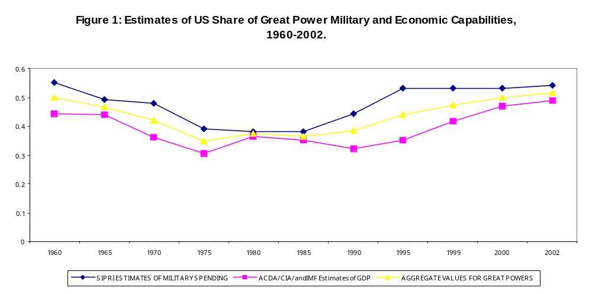 Figure 1 summarizes U.S. relational capabilities, as shares of great power economic and military capabilities. U.S. relational strength among the great powers is overwhelming, whether in the aggregate or in disaggregated forms. For our most recent data point, U.S. relational capabilities are in excess of 50 percent of all great power strength.
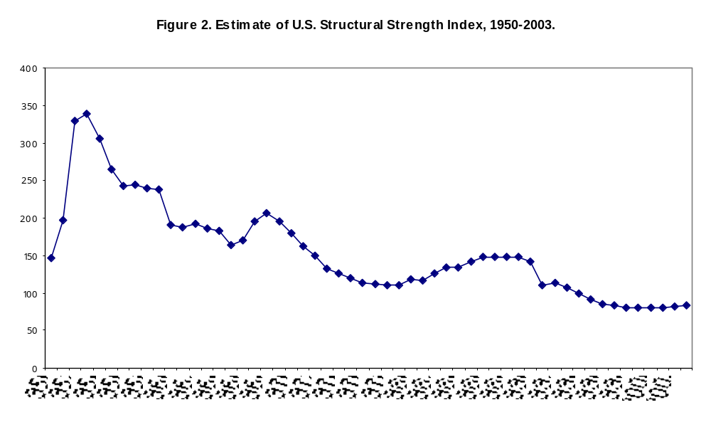
A very different picture emerges when we view strength from a structural perspective, as seen in Figure 2. Here, the focus is on the amount of resources made available to foreign activity as modified by both domestic constraints and international system complexities (for example, the growth in system membership, and the extent of state autonomy as measured by its international trade dependence as a percentage of its GDP)
The picture conveyed by the U.S. structural strength index is one of dramatic decline. The drop in structural strength is nearly monotonic over time, and rather than a picture of stable unipolarity, we have one in which resources for foreign policy activities by the U.S. have not kept up with changing global circumstances…including the growth and complexity of the international system and the increased loss of autonomy created by growing dependence on international trade. If the measure is a valid one of the strength used to fashion global architecture and help create new rules and norms for the system, then its low levels since the 1970s, and especially since the end of the Cold War suggest insufficient structural strength for the U.S. to act hegemonically unless it is successful in integrating its resources with those of like-minded core allies.

Policy Dissension within the G7

The G7 was created during the mid-1970s, to respond to potential systemic disturbances, and not coincidentally at a time when both U.S. structural strength and relational strength were in decline. The willingness of the G6 to enter into this institutional arrangement was no doubt facilitated by the reality that the other members of the group were also experiencing declining capabilities vis-à-vis the rest of the world. Created as a partnership between states in the economic realm (where the U.S. was the strongest but less than predominant), the G7’s scope has gradually extended into the political/military realm (where the U.S. is much stronger than the other actors). The norms of partnership from the economic realm have been carried over to a variety of non-economic matters.
When acting together, the G7 controls a predominant share of military and economic capabilities in the international system, sufficient capabilities with which to shape the contours of international politics, I a manner that the U.S.simply may not be able to accomplish with its own structural strength. That is why, elsewhere, we have referred to the period between 1975 and 1997 as a period of “group hegemony”, in which the G7 acted as an important institutional mechanism for system maintenance purposes and for designing a new global architecture, albeit incrementally.
Accordingly, we view the G7 as a critical mechanism to supplement missing U.S. structural hegemonic strength. Yet, that supplement may not be forthcoming unless there is substantial policy congruence between G7 members. Although the G7 is now deeply institutionalized, challenges within the G7 to U.S. leadership are likely if and when policy cohesion is substantially diminished.
As Davis Bobrow highlights in Chapter one, there has been a history of disagreement with U.S. strategies and policy preferences, even among states identified as “America’s closest ‘kin’”, a label clearly represented by the members of the G7. More recently, the events leading up to the invasion of Iraq underscored substantial divisions between the United States and its G7 partners. While Britain remained a staunch ally of the U.S., and eventually Japan and Italy chose to support (albeit nominally) the war option, Germany, France, and Canada resisted American initiatives toward a war-based approach to regime change in Iraq. With the exception of Tony Blair’s enthusiastic support, the “coalition of the willing” was to be found overwhelmingly outside of the G7.
The policy dissension over Iraq is not without precedent. After the end of the Cold War, French policy makers have consistently questioned American leadership, challenging what they perceived as American hegemony. French, German and (even) British policy makers agreed—after the dominant role of the U.S. in the Bosnian conflict—to create an “independent” military capability for the European Union separate from NATO (and U.S. and Turkish) control. American withdrawal from the Kyoto Protocol has been denounced by most G7 states. Japan has at times challenged American leadership in the global political economy, for example by at one time seeking (in cooperation with China) an alternative financial structure to the IMF in Asia.
Furthermore, policy disagreements between the U.S. and its G7 colleagues predate the end of the Cold War. French initiatives for an independent foreign policy highlighted its relations with the United States as early as the 1960s, and as late as 1986 when France denied “overflight” privileges to U.S. warplanes attacking Libya. Willie Brandt’s policy initiatives toward the Soviet Union and East Europe predated moves toward détente between the Soviet Union and the United States. For the Italian government, American involvement in Beirut in the early 1980s stimulated major policy differences with the U.S. toward the Middle East and Israel. Descriptions of such disagreements fill the pages of analyses of transatlantic relationships.
Nevertheless, we should be mindful of the larger dynamic uniting G7 states: policy disagreements have co-existed within a substantially broad range of policy congruence among these status quo powers. For the most part G7 state have been satisfied with the direction of affairs in international politics. Policy agreements are critical for the G7 to act in concert. The fact that it has often done so indicates that policy disagreements have neither been sufficiently disruptive to destroy the ability of the G7 to act in concert.
Yet, troubling questions remain. How much policy cohesion remains in the G7 when one of the pillars of cohesion—the Cold War—has disappeared? How can we account for its diminution when that does occur? For the first question, we look at two types of data that provide a longitudinal perspective on policy cohesion between G7 states. One points to similarity of preferences by identifying alliance portfolios. The second approaches preferences through an examination of similarities in voting patterns in the General Assembly of the United Nations.
Alliance portfolios have been used previously to indicate similarities in policies and orientations to international relations. Annual observations are available for most states, and there is a substantial history of data validity and reliability. The major disadvantage to this approach, however, is that a state’s alliance portfolio is not sensitive to rapid fluctuations in the international environment. Nevertheless, with such caveat in mind, an analysis of the alliance portfolios of G7 states clearly demonstrates a substantially similar policy orientation, showing disruptions only in response to major fluctuations in the international environment (e.g., the end of the Cold War. The absence of policy dissension—except in response to major turbulence—suggests to us that this measure of policy congruence is insufficiently sensitive to the range of policy disagreements within the G7. Therefore we turn to a second measure, both more controversial but also potentially more sensitive to fluctuations in policy disagreements: commonality in voting on resolutions in the UN General Assembly (UNGA).
While this is a less than ideal way to measure policy cohesion between states, the votes cast on UNGA resolutions usually reflect for powerful states—generally satisfied with the status quo—little more than their policy preferences on issues. While the UNGA may be a quasi-legislative arena by some UN members, that is not the case for the strongest of states; few (if any) incentives exist for strong states to deviate from their policy preferences when voting in the UNGA.We find no alternative measure and data set available which provides consistent observations of the G7’s policy preferences over the lifetime over the G7 and over a broad range of issues.
Essentially, there are two methods for assessing the cohesiveness of policy preferences through voting in the UNGA. One uses factor analysis; the other develops a group defection ratio. Factor analysis allows for an empirical, inductive clustering of votes on a variety of dimensions that show the relative cohesiveness of a group of states on those dimensions. Unfortunately, factor analysis limits our observations in two crucial ways. First, given the type of data we have on UNGA voting, factor analysis can at best provide snapshots aggregated to several years rather than annual observations. Second, the method itself generates data that discount a large percentage of contested votes, often dismissing as much as 50 percent of the “explained variance” in voting. Its strength on the other hand lies in identifying dimensions of voting over time and the extent to which policy congruence changes on the most salient ones.
Figures 4 and 5 illustrate both the strengths and weaknesses of he factor method.29 The two primary dimensions of voting in the UNGA in both the 1990-92 period and the 1997-99 period consisted of a North-South and a Middle East dimension. Figures 4 and 5 illustrate very strong policy congruence between all G7 states on the first dimension, and substantial variation between the United States and the G6 (and within the G6) on the second dimension in both time periods.
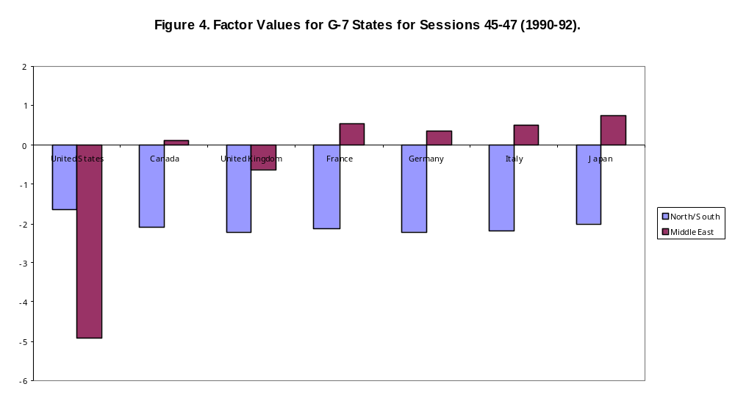 Alternatively, we examine cohesion by creating a group value for each year’s votes, and then estimate defections from the group’s voting norms. Previous research examining the cohesion of Third World states in the UNGA used a defection ratio measure to estimate the deviation of individual members from a common group position and we use the same defection ratio. 30
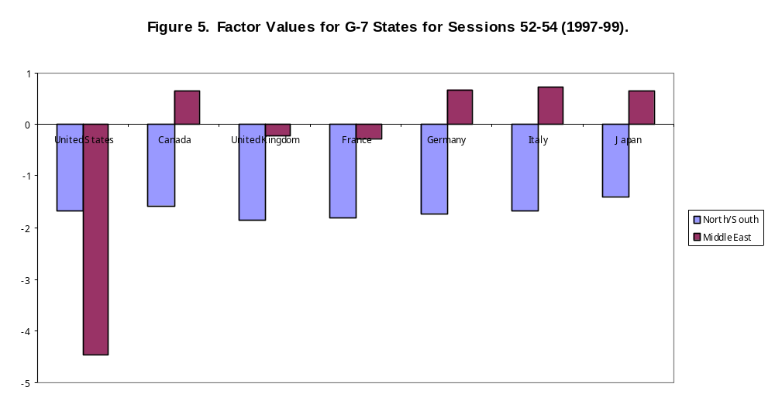 Figure 6 displays annual defection ratio for the G7 from its inception through 2003. We include in the figure the defection ratio for the UNGA as a whole to allow for a comparison between the relative cohesiveness of the G7 and an Assembly that is meant to be relatively cohesive. We also display “individual” state defections in Figure 7.
Figures 6 and 7 reveal considerably more variation in policy congruence than would have been indicated by alliance portfolio data, although there is some correspondence (and therefore a bit more validation for the voting measure) between the two. For example, the alliance portfolios indicate that Japan is most remote and the UK is most proximate to the United States. The voting data average scores on individual state defections reflect these relationships. In a similar vein, as the congruence of alliance portfolios declines after the end of the Cold War, so does voting congruence with the U.S. after 1989 for all the G6 states.
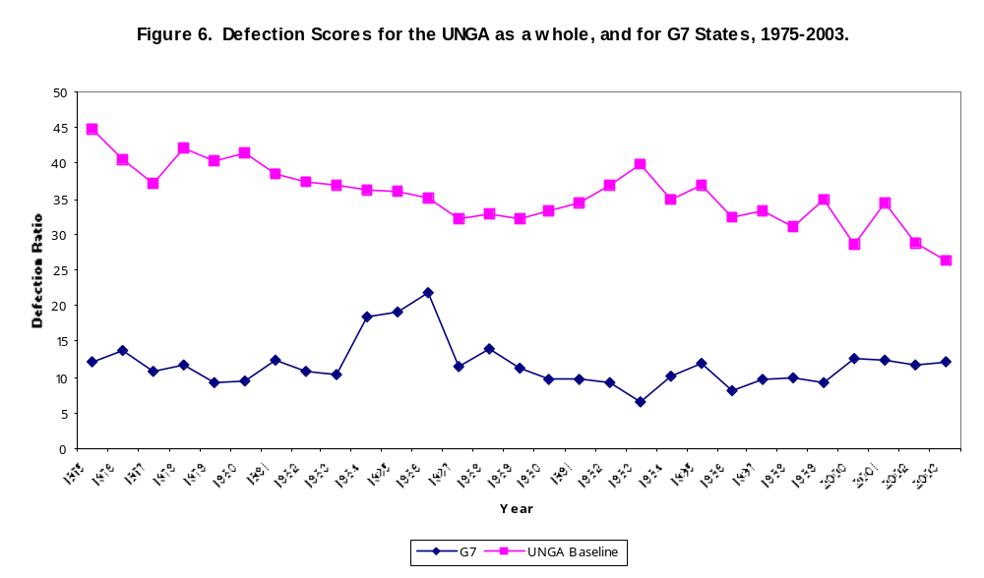 Two trends are worthy of further note. First, while policy disagreements with the Bush II administration are clearly noticeable in the data (showing post-Cold War level highs in defections among G7 states), they appear to indicate a broader pattern of growing policy disagreements with post-Cold War American administrations. Although the Iraqi war and the policy disagreements over American use of coercion to achieve regime change were most debated publicly, a substantial amount of policy disagreement already existed as it did prior to 9/11. Second, the pattern of defections continues to underscore substantial underlying policy agreements between the G7 states compared to the level of policy agreements within the global community as a whole (note Figure 6). This is consistent with the notion that the G7 includes primarily very powerful states that benefit from the global status quo.
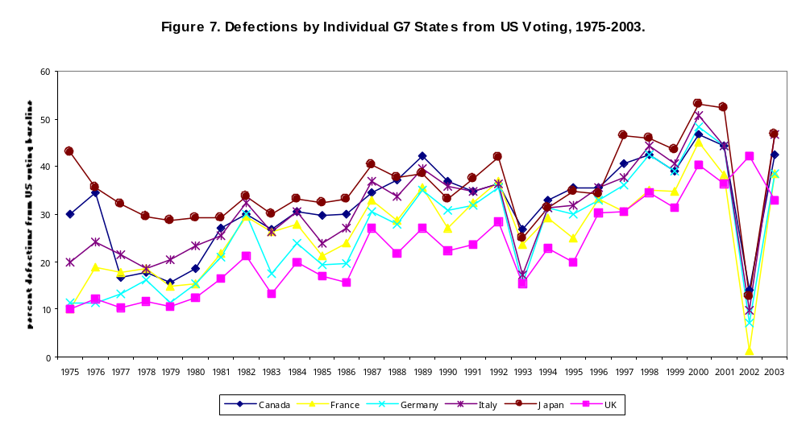
Accounting for Policy Dissension Within the G7
The evidence presented, including both the factor analysis and defection ratio results, offer a two-fold image regarding policy cohesiveness within the G7, and consequently for concurrence with U.S. hegemonic leadership. On the one hand, there has been—and continues to be—a substantial amount of policy cohesion within the group. On the other hand, there is significant variation in cohesiveness, both before and after the Cold War. While there is a notable decline in policy support of hegemonic preferences after 1989—with the collapse of the Cold War pillar of the status quo—the post 1989 period has not been the only period of significant policy dissent. Although there is more individual deviation from U.S. preferences after 1989, the substantial variation in policy congruence before the end of the Cold War is consistent with Bobrow’s injunction in Chapter One that challenges to US. global leadership are a phenomenon not unique to present circumstances.
Our primary task then becomes discerning reasons for variation in G7 policy cohesiveness across both Cold War and post-Cold War periods. Recall that the G7 was created in the belief that the institutionalization of the group, in the context of common policy preferences toward the status quo and within a framework of overwhelming strength, would allow the group to respond to systemic disturbances and challenges to the international status quo, and help create new norms and rules when needed. Three types of systemic disturbances that the G7 envisioned were interstate wars, crises, and turbulence within the global economy. These are “typical” disturbances in the sense that much of international politics has been historically focused on these phenomena. Much of the cohesion the G7 has historically demonstrated was due to the similarity in policy preferences of states relatively satisfied with the status quo in response to traditional systemic disturbances. Therefore, we do not expect interstate wars, interstate crises, and global economic threats to impact negatively on G7 cohesiveness.
Instead, the cohesiveness of G7 policy preferences is more likely to be tested by relatively new systemic disturbances to the status quo. Two such disturbances are international terrorism and intrastate conflicts. Both are relatively “new” in international politics, at least in their scope and the growth of their impact on relations between states.
While terrorists have acted throughout the history of international politics, the sheer magnitude of recent international terrorist activity since 1968, presents disturbances relatively new to the international system. As the events of September 11, 2001 demonstrated, international terrorism has come to rival—if not surpass—interstate wars in its potential to disrupt international politics.
International terrorism has clearly left its mark on the last third of the 20th century. An average of over 400 international terrorist acts annually have been recorded by the U.S. State Department since 1968. The U.S., the one G7 state relatively immune to international terrorism on its own soil, experienced the shock of the destruction of the World Towers. Even before 9/11, while the frequency of terrorism declined in the 1990s compared to earlier periods, the level of violence per attack increased significantly.
The growth in the volume of intrastate war qualifies it as another new type of systemic disturbance, one that has become a numerically far larger threat to the status quo than interstate wars. In the 19th century, roughly 60 percent of all wars were international in character. By the last third of the 20th century intrastate wars constituted 70% of all conflicts. Nor are intrastate conflicts infrequent. Over the last quarter of the 20th century, nearly three such conflicts occurred per year, at a total loss of nearly nine million lives, compared to less than 1.3 million lives lost in interstate wars.. Furthermore, intrastate violence contributes substantially to turbulence internationally as it often results in large migration flows that create additional ethnic conflicts, militarized interstate disputes, and occasionally interstate wars.
Both of these disturbances pose substantial challenges to the international status quo and to the G7’s leadership and maintenance of global relations. As relatively new phenomena, they challenge existing institutional mechanisms within the G7. Involving essentially non-state actors, they threaten historically embedded norms and rules regarding the primacy of interstate relations. What explains variation in the cohesiveness of the G7 under these conditions?

Domestic Politics and Foreign Policy Congruence
Our primary approach to policy makers’ responses to new systemic disturbances is from the perspective of domestic politics.43 This perspective suggests that key foreign policy makers are domestic political actors, and while they may pursue critical foreign policy objectives, they are at least as motivated by domestic political considerations, and view new systemic disturbances through domestic political lenses at least as much as foreign policy ones.
From a domestic political perspective, all new systemic disturbances are not alike. We suggest that there are at least three types. First, there are disturbances with minimum immediate and/or long term domestic political consequences. Second, there are disturbances with similar substantial short and long-term domestic political consequences in all of the G7. Third, there are disturbances with varying, substantial domestic political consequences for G7 members. Fashioning policy congruence among the G7 to systemic disturbances that have minimal domestic political costs or have similar domestic political costs should not pose great difficulties. Systemic disturbances laden with different but large domestic political costs for G7 members are the ones most likely to create policy dissension and defections from U.S. policy preferences.
We think that this is what has been happening when G7 members entertain a collective response to international terrorism. This issue carries with it at least two types of non-uniform domestic political consequences for G7 members: selectorate turmoil and domestic security risks. Terrorism carries the potential of selectorate turmoil by creating increased conflicts within the selectorates and winning coalitions that determine the political fortunes of G7 governments. G7 states vary greatly in the nature and composition of their selectorates—for example in the size of their Arab and Muslim populations. Those sub-groups may withhold support from their governments in solidarity with groups being targeted as terrorists from the Middle East. Just as difficult from a political perspective would be when such electoral groups clash with others within the domestic political system over Middle East issues. France, for example has nearly ten percent Arabs and Muslims within its population, while Japan’s is negligible. We do not expect a uniform impact on the G7 through such selectorate turmoil, but that is precisely the point: different domestic electoral situations will lead to different foreign policy positions on international terrorism.
A second domestic political consideration regarding terrorism involves varied perceptions and experiences of domestic security risks If G7 members articulate strong common policy responses to terrorism, they run the risk of increasing terrorist violence affecting all members of the group. Foreign policy makers experiencing little or no terrorist activity at home risk becoming terrorist targets, and—through their foreign policy decisions—of alienating their selectorate for having increased national insecurity. Even for those G7 members with extensive previous experiences with terrorism, there is considerable variability in success in dealing with it, and the willingness to risk more incidents by partaking in a common, U.S. favored counter-terrorism policy.
We do not expect such domestic political considerations to impact uniformly on all G7 states. Britain, for instance, with a long history of terrorist experience is likely to respond differently than Japan. American policy makers, post-9/11 are likely to see terrorism in a different light than the French, who survived the terrorist attacks of the 1980s and 1990s, and may be less likely to take the risk of another round on French soil. Domestic political considerations regarding security may drive an American president and a French president to far different policy perspectives in the aftermath of tragedies such as 9/11.
Accordingly, we see international terrorism as being laden with varying domestic political costs for G7 members. As a result, we expect that increasing levels of international terrorist activity will be associated with less policy cohesion within the group, and pose conditions conducive to G6 challenges to U.S. leadership in counter-terrorism.
Our expectations about how the G7 address intrastate conflicts are very different because their impact on the domestic politics of G7 members falls into a different category than that of international terrorism. Most intrastate conflicts will either not translate directly into the domestic politics of G7 states (e.g., the recent Sudanese civil war) or if they do, they will likely have a uniform domestic political impact on most G7 states (for instance, a civil war in Saudi Arabia may have uniform consequences for all G7 states). Of course some cases of intrastate conflict may resemble international terrorism in having differing domestic political impacts on G7 members (e.g. the conflicts in Bosnia and Kosovo). These are, however, likely to be relatively rare instances compared to the variation in domestic consequences of international terrorism.
Accordingly, our domestic politics approach should be of significant help in accounting for G7 responses to international terrorism, but not for ascertaining G7 policy congruence in dealing with intrastate conflicts. For this reason, we turn to two other explanatory frameworks.
Alternative Perspectives
Due to their prominence in theorizing about international relations, we turn to two alternatives that may help account for fluctuations in the policy cohesiveness of the G7. A realist/neorealist explanation would emphasize the relative strength of the dominant actor (the U.S.) in a group (the G7); a liberal/institutionalist explanation, patterns of institutionalized cooperation within the group to respond to potential threats to the status quo. Plausibly, these alternatives can challenge the value of the domestic politics explanation and shed light as well on G7 responses to intrastate conflicts.
While realist/neorealist accounts of conflict and cooperation (where cohesion is one aspect of cooperation) come in many forms,49,they share a primary focus on the relative power capabilities of major actors in international affairs while disagreeing on how power and relative strength matter. Hegemons, or states with asymmetrically strong capabilities may deter conflict with potential competitors and foster cooperation through leadership.50 Alternatively, sustained periods of predominance can foster coalitions against a dominant nation.51 Relative parity between states may foster much greater competition—all things being equal—among states than asymmetrical power relationships.52 Additionally, power transitions between states may be symptomatic of ongoing challenges to the lead nation and the global status quo, or the dynamics of such transitions may motivate (dissatisfied) states to reconsider their roles and opportunities, leading to greater conflict between states.53
While using competing concepts and operational measures, and having at times contradictory results, 54 the idea that power and relative strength matter in shaping patterns of conflict and cooperation between major states continues to enjoy currency in the literature and at first glance appears relevant for an analysis of G7 cohesiveness. Since the U.S. is the strongest of the G7 actors, variation in its strength relative to the group should influence the group’s cohesiveness. As American strength increases, its ability to dominate how G7 actors view and respond to global circumstances should be enhanced. The more other G7 states reach parity with the U.S., the more they may question American policy positions. The G7’s policy cohesiveness when faced with either intrastate conflicts or international terrorist threats may covary with relative American strength.
The liberal/institutionalist tradition offers yet another perspective. Most relevant here is John Ikenberry’s theorizing about the dynamics driving the creation and maintenance of global order mechanisms.55 Institutions of international governance are possible because members benefit more from cooperation relative to the cost of participation and the surrendering of some autonomy, and gain when the major power in the system (such as the U.S.) surrenders some sovereignty through its willingness to abide by institutional rules (rules that are consistent with its own interest). Thus, irrespective of power differences, members cooperate through major institutional arrangements, and do so to help perpetuate their interests. For the G7, that interest is warding off threats to the status quo.
Given a successful, institutionalized history of cooperation between G7 members, and all else being equal, the members will continue to use existing institutional mechanisms and respond similarly to systemic disturbances and threats to the international status quo. The G7’s cohesion would increase when such threats occur. Intrastate conflicts should stimulate increasing G7 cohesion, since such conflicts have substantial consequences for immigration flows, intrastate and interstate ethnic conflicts, militarized interstate disputes, and even interstate wars, all with substantially negative consequences for the status quo.
Analyzing the Evidence
Our UNGA voting measure of defections (designated in the test that follows as “defect”), reported in Figure 6, constitutes our dependent variable. We use four independent variables to predict changing levels of G7 cohesion. The first is simply the defection ratio lagged (the variable “LDR”). We use it to assess the extent to which the previous level of cohesion may have an impact on the present level.56
A second independent variable assesses the relative strength of the U.S. vis-à-vis the rest of the G7using an aggregate measure that is the average of U.S. military spending and GDP, divided by the index for the group (the variable “LUSRS”) and lag it one year behind the other variables.57 The third independent variable deals with the frequency of intrastate conflicts annually in the international system (labeled “DMCON”).58 The fourth independent variable is based on annual frequencies of international terrorist acts (labeled as “TERROR”), and is drawn from the U.S. State Department’s public reporting of international terrorist incidents.59 Overall, we use the following model to predict defections: Defect = LDR – LUSRS – DMCON + TERROR.
In addition to the base model, we applied regression analysis, as shown in Table 1 to three others. The external disturbance model is meant to capture a range of interstate challenges to the status quo. The “factored-in” model represents the cumulative effects of interstate wars and crises on levels of defection. The mixed disturbance model focuses on both domestic and external disturbances. We test these alternative models for two reasons. First, crises and interstate wars61 already may be “factored” into the policy cohesiveness of the group and thus would be unlikely to predict to variation in G7 defection scores. This argument finds support in equation 2a. Second, these disturbances may amount to exogenous considerations that alter policy commonalities between G7 members. That is, they may nullify the predicted relationship between policy cohesion, intrastate conflicts and terrorism by giving priority to more established concerns about crises and wars. If, however, the relationships predicted by our base model are robust, then we should be able to find them even in models that include disturbances such as crises and interstate wars (as equations 2 and 3 assess these possibilities).

Table 1: OLS Regression Equations for G7 Defection Ratios with Selected Independent Variables
 | Equation 1  (Predicted Model) | Equation 2  (External Disturbance Model) | Equation 2a  (Factored-In Model) | Equation 3  (Internal/External Disturbance Model)
LDR | .022  (.107)
TERROR | .021***  (.006) | .022***  (.007) |  | .021***  (.006)
LUSRS | -5.542  (24.975) | .601  (30.586) |  | -9.739  (28.5)
DMCON | -.238*  (.116) |  |  | -.237*  (.115)
CRISES |  | -.04  (.206) | .201  (.185) | -.068  (.187)
WARS |  | -.447  (.651) | -.087  (.755)
Constant | 5.046  (12.107) | 2.023  (15.044) | 10.45***  (1.456) | 7.396  (14.048)
R² | .49 | .40 | .05 | .49
Adjusted R² | .39 | .28 | .03 | .39
Probability > F | .007 | .029 | ns | .007
N | 25 | 25 | 26 | 25
* p = .06 ** p ≤ .01 *** p ≤ .001 (Standard Errors in parentheses)
Table 1 shows that, consistent with our predictions, the models yield no significant relationship between varying levels of U.S. relational strength and variation in G7 defection scores. Relational strength seems to contribute little to policy cohesion in the G7.62 Second, the results for the predicted model indicate that lagging the defection ratio adds little to the amount of variation explained. Unsurprisingly, the group’s prior level of defection does not predict to its present level of defection. This should come as no surprise: UNGA resolutions change substantially from year to year, and G7 responses to these resolutions are primarily a function of policy preferences rather than legislative dynamics that may endure across session of the UN.
Third, variation in the frequency of intrastate conflicts does have a modest impact on the group’s defection ratio. The relationship between this variable and the defection ratio is negative, as expected for the predicted model and the internal/external disturbance model, suggesting that increased levels of intrastate conflict are associated with modest decreases in the group’s defection ratio.
On the matter central to the previous domestic politics reasoning, however, there is a very strong, negative relationship between the frequency of terrorist activity and G7 cohesiveness, as demonstrated by its significance level and positive relationship with the defection ratio. The relationship is dramatically evident for the predicted, external disturbance, and the internal/external disturbance models. We reasoned earlier that there are substantial differences between G7 members in the anticipated domestic political costs for a unified approach to international terrorism. We expected to find substantial policy differences in response to increased international terrorist activity, and that is precisely what Table 1 shows. 63
Finally, as suggested by the results for the factored-in model, the typical systemic disturbances of interstate wars and crises appear to have no significant impact on the G7’s defection ratio. As noted earlier, those types of events have long been of concern to the G7, and appear to act more as constants than variables in accounting for G7 policy cohesion. Results for the external disturbance and the internal/external disturbance models suggest that neither variation in crises or interstate wars reduce the impacts of intrastate conflicts and terrorist activity on the G7’s defection ratio.

The Future of G7 Policy Congruence and Challenges to the U.S.
Our findings suggest a number of conclusions regarding the likelihood that even within the G7 we will find increased challenges of evasion, modification, and even resistance to U.S. leadership in the future.
The typical “old” systemic challenges to the status quo are likely to be met with a relatively unified policy response in the near future, as they have been in the past.64 G7 states will likely exhibit similar policy preferences when major interstate conflicts erupt, interstate crises threaten established norms of international affairs, or international economic turbulence threatens the wellbeing of G7 states. These types of issues will continue to generate relative consensus and little resistance to US leadership as long as the US continues to employ the G7’s institutions, and pursues its own policies in consultation with its G7 partners (although such consultation has been severely questioned over U.S. Iraqi policy).
The greater dangers for policy defection and G6 challenges to U.S. leadership revolve around issues that are relatively new for which there are no well developed, relatively successful, institutionalized group responses, and ones that pose differential and significant domestic political consequences for the member governments.
International terrorism is one such divisive issue. While there has been substantial collaboration between G7 members in certain areas (e.g., hindering terrorist economic networks and sharing of intelligence), more visible tactics in the hunt for terrorist organizations and states that may harbor them is likely to continue to create major rifts.
Although clearly not the identical issue, nor one that is particularly new, the Middle East conflict, and especially the relationships between Israel, Palestine, and their surrounding neighbors, is fraught with consequences similar to the issue of international terrorism. Throughout the Cold War and its aftermath, U.S. leadership on this issue has been aggressively challenged by some of the G7 members and, as shown in Figure 7, has substantially split the group. We suspect that a significant reason again involves the domestic political consequences associated with this international issue. Those differences have not yet split the G7 on a permanent basis. Now, however, the intersection between this issue, the ongoing conflict in Iraq, and differences over how to combat international terrorism makes it more problematic than before for G7 partners. Even as staunch an ally as Tony Blair has demanded that the U.S. create a new peace process in the Middle East in exchange for continued British support in Iraq. Joint German, French, and British efforts under a common EU umbrella to negotiate Iran’s nuclear capabilities—coupled with a skeptical response by the U.S.—underscore further the divisive nature of the Middle East for G7 partners.
It is likely as well that US leadership also will be challenged in other issue areas, particularly when domestic political consequences divide the G7. Global ecological issues, as manifested for instance in conflicts over the Kyoto Protocol (discussed in Chapter Nine) constitute both a relatively new issue area for the G7 and have substantial domestic political consequences for member states with large “green” groupings within their selectorates. Even for US policy makers, political support within the current winning coalition appears to be critically dependent on domestic actors unwilling to risk the economic impact of joining the protocol.
Changes to the membership of the G7 constitute another potential problem for continued policy cohesion. With the exception of Japan, the other members of the presently constituted group carry very similar alliance portfolios, reflecting similar orientations to international affairs. All of the G7 are democracies, with widely varying selectorates but similar democratic processes determining the fortunes of political leaders. That is not the case with Russia, the next state likely to become a full member of the group. Russian domestic politics play out with dramatically different rules than those of the G7 states and Russian policy makers are likely to respond with different domestic imperatives in mind.65 This divergence is likely to be magnified by a generic Russian orientation to international politics substantially different from that of the original G7 members.66
China’s addition to the G7 would amplify even further these differences. China would bring a new group of policy makers to the G7 table, responsive to a pattern of domestic politics with even a smaller selectorate than that of Russia, and even less exposed to democratic processes. Further, its foreign policy preferences have been demonstrably different from not only the G7, but Russia as well.67 It is not likely that an institution historically based on the relative homogeneity of its members—both in terms of preference for the international status quo, and the democratic nature of their polities—would be able to survive such a challenge to its cohesiveness.
Finally, there is much that remains unexplained by the previous analysis. Whille, statistically speaking, they account for nearly half of the variation in our best model—an outcome that is substantial given no more than four variables per equation—nearly half of the variation in G7 cohesion remains unexplained. The power of our predicted model, based on the domestic politics approach may well be substantially increased by inserting one of the missing elements often used in domestic politics explanations for foreign policies: the foreign policy orientations that new political elites bring to office.68 Clearly, foreign policy makers are more than just domestic political actors. They also bring with them into office policy orientations and interests that are likely to vary across the G7 states.
Who is in office is likely to matter, but in the context of broader forces working in domestic and international politics. For example, the foreign policy orientations found in the Bush administration, tempered by domestic political dynamics, is far from being identical to the foreign policy orientations of the Clinton Administration. As long as domestic political imperatives and external pressures would have remained the same across the two administrations, fundamental differences in policy orientations may have been difficult to detect. As contexts and pressures changed, as they obviously did after 9/11, foreign policy orientations favoring more unilateral action and regime change came to the fore in the Bush II administration in a manner quite different from what would have likely played out under a Clinton or a Gore administration with different policy preferences. Obviously, building in policy makers’ preferences should improve the predictive capability of our model to predict G7 policy cohesion.
To conclude, arguments and evidence have been presented that underscore the importance of varying domestic political conditions for policy congruence with and divergence from the U.S. in the G7. While much remains to be done, it seems clear that domestic factors play a central role in determining the issues, and the governments, that will mount challenges to U.S. policy preferences from within the core of the American-centered part of the international system.

REFERENCES
Bennett, D. Scott, and Allan Stam. 2000. “EUGene: A Conceptual Manual.” International Interactions 26:179-204. Website: http://eugenesoftware.org.
Bennett, Scott and Matthew Rupert. 2003. “Comparing Measures of Political Similarity: An Empirical Comparison of S Versus Τ_{b} in the Study of International Conflict.” Journal of Conflict Resolution 47(3): 367-93.
Ben-Yehuda, Hemda, and Meirav Mishali-Ram. 2003. “The Ethnic-State Perspective in International Crises: A Theoretical Framework Applied to the Arab-Israeli Conflict, 1947-2000.” International Interactions, 29:1-26.
Bergsten, Fred. 2000. “Toward a Tripartite World.” The Economist (13 July): 23-6.
Brophy-Baermann, Bryan, and John A.C. Conybeare. 1994. “Retaliating Against Terrorism: Rational Expectations and the Optimality of Rules Versus Discretion.” American Journal of Political Science, 38:196-210.
Bueno de Mesquita, Bruce. 1975. “Measuring Systemic Polarity.” Journal of Conflict Resolution 19: 187-216.
Bueno de Mesquite, Bruce. 2003. Principles of International Politics: People’s Power, Preferences, and Perceptions. Washington DC: Congressional Quarterly Press.
Bueno de Mesquita, Bruce. 2002. Predicting Politics. Columbus: Ohio State University.
Bueno de Mesquita, Bruce and David Lalman. 1992. War and Reason. New Haven, CT: Yale University Press.
Bueno de Mesquita, Bruce, James D. Morrow, Randolph M. Siverson, and James Smith. 2000. “Political Institutions, Political Survival, and Policy Success.” In Bruce Bueno de Mesquita and Hilton Root, Governing For Prosperity. New Haven: Yale University Press.
Davenport, Christian A., Will H. Moore and Steven C. Poe. 2003. “Sometimes You Just Have to Leave: Domestic Threats and Forced Migration, 1964-1989.” International Interactions 29: 27-56.
Haggard, Steph, and Beth Simmons. 1987. “Theories of International Regimes.” International Organization 41:491-517.
Hasenclever, Andreas, Peter Mayer, and Volker Rittberger. 1996. “Interests, Power, Knowledge: The Study of International Regimes.” Mershon International Studies Review 40 (Supplement 2):177-228.
Hodge, Carl Cavanagh. 2004. Atlanticism for a New Century. Upper Saddle River: Prentice Hall.
Hoffman, Bruce. 2003. “The Logic of Suicide Terrorism.” The Atlantic Monthly, June 2003:40-7.
Huth, Paul, Christopher Gelpi, and Scott Bennett. 1993. “The Escalation of Great Power Militarized Disputes.” American Political Science Review 87(3): 609-23.
Iida, Keisuke. 1988. “Third World solidarity: the Group of 77 in the UN General Assembly.” International Organization 42:375-95.
Ikenberry, G. John. 2001. After Victory. Princeton: Princeton University Press.
Ikenberry, John G., and Charles A. Kupchan. 1990. “Socialization and Hegemonic Power,” International Organization 44:273-290.
Keohane, Robert O. 1984. After Hegemony: Cooperation and Discord in the World Political Economy. Princeton: Princeton University Press.
Keohane, Robert O., and Helen Milner. 1996. Internationalization and Domestic Politics. Cambridge: Cambridge University Press.
Lake, David A. 2004. “Hierarchy in International Relations: Authority, Sovereignty, and the New Structure of World Politics.” Prepared for the Annual meeting of the American Political Science Association: Chicago.
Lindstrom, Gustav. 2003. Shift or Rift: Assessing Us-EU Relations after Iraq. Paris: European Union Institute for Security Studies.
Martin, Lisa L., and Beth Simmons. 1999. “Theories and Empirical Studies of International Institutions.” In Robert O. Keohane and Stephen D. Krasner, Exploration and Contestation in the Study of World Politics. Cambridge: MIT Press.
Mastanduno, Michael. 1997. “Preserving the Unipolar Moment: Realist Theories and U.S. Grand Strategy After the Cold War.” International Security 21:49-88.
Muller, Harald. 2003. “Terrorism, proliferation: a European Threat Assessment.” Institute for Security Studies, Chaillot Papers (58).
Risse-Kappen, Thomas. 1991. “Public Opinion, Domestic Structure, and Foreign Policy in Liberal Democracies.” World Politics 43: 143-75.
Russett, Bruce, and Soo Yeon Kim. 1996. “The New Politics of Voting Alignments in the UN General Assembly.” International Organization, 50, 629-52.
Sarkees, Meredith Reid, Frank Whelon Wayman, and J. David Singer. 2003. “Inter-State, Intra-State, and Extra-State Wars: A Comprehensive Look at Their Distribution over Time, 1816-1997.” International Studies Quarterly, 47:49-70
Signorino, Curtis S. 1999 and Jeffrey Ritter. 1999. “Tau-b or not tau-b: Measuring the similarity of foreign policy positions.” International Studies Quarterly 43: 115-44.
Spiezio, K. Edward. 1990. “British Hegemony and Major Power War, 1815-1939: An Empirical Test of Gilpin’s Model of Hegemonic Governance.” International Studies Quarterly 34:165-81.
Strange, Susan. 1989. “Toward a Theory of Transnational Empire.” In Ernst-Otto Czempiel and James N. Rosenau (eds.). Global Changes And Theoretical Challenges: Approaches to World Politics for the 1990’s. Lexington: Lexington Books.
Talbot, Brent J. 2004. “American-Led Coalition or Unilateral Action? The Question of American Hegemony in the 21st Century.” Paper presented at the Annual Meeting of the International Studies Association, Montreal, March 17-20.
Voeten, Erik. 2000. “Clashes in the Assembly.” International Organization, 54:185-215.
Volgy, Thomas J. and Lawrence E. Imwalle. 1995. “Hegemonic and Bipolar Perspectives on the New World Order.” American Journal of Political Science 89:819-32.
Volgy, Thomas J., and Lawrence E. Imwalle. 1999. “Where is the New World Order? Hegemony, State Strength, and Architectural Construction in International Politics.” Journal of International Relations and Development 5: 51-70.
Volgy, Thomas J. and Alison Bailin. 2003. International Politics and State Strength. Boulder: Lynne Rienner.
Volgy, Thomas J., Derrick V. Frazier, and Robert Stewart Ingersoll. 2003. “Preference Similarities and Group Hegemony: G7 Voting Cohesion in the UN General Assembly.” Journal of International Relations and Development 6:51-70.
Volgy, Thomas, Kristin Kanthak, Derrick V. Frazier, and Robert Stewart Ingersoll. 2004. “The G7, International Terrorism and Domestic Politics: Modeling Policy Cohesion in Response to Systemic Disturbances.” International Interactions 20 (forthcoming).
Waltz, Kenneth N. 1979. Theory of International Politics. New York: Random House.
Waltz, Kenneth N. 1993. “The New World Order.” Millennium 22:187-95.

? We assume that the United States continues to be an actor committed to the status quo, even after the end of the Cold War. This assumption is made for a number of reasons, including our belief that it derives enormous benefit from the institutions it built and the policies it pursued with respect to security and economic issues during the Cold War. Since 1989, its strength has increased vis-à-vis other “major powers” and yet it has not sought to engage in a comprehensive set of changes to global institutions created during the Cold War (e.g., see Volgy and Bailin, 2003), even though substantial lip service has been paid to a “new world order”. Attempts to develop major new global regimes involving environmental and human rights issues have been strongly resisted by U.S. policy makers.
We refer to this condition as critical but not “necessary”, since realists and neorealists argue that even without policy disagreements, others may resist hegemony for balancing purposes. Yet, we are not aware of many situations in the recent history of international politics where such “balancing” was not accompanied by policy disagreements.
One could argue further that policy dissension is a weak form of resistance in as much as the larger powers through dissenting can rationally view their actions as making it more difficult for the hegemon to pursue its preferences while also signaling unwillingness to cooperate. In either case, the hegemon may have to modify its preferences accordingly.
See Bailin, 2003; Volgy and Bailin, 2003.
The term G7 refers to the original seven members: Canada, France, Germany, Italy, Japan, the U.K., and the United States. When referring to the G8, we include Russia as a new member, at least in a symbolic sense. Reference to the G6 indicates the other six original members, without the United States.
We consciously avoid the term “power” in favor of the more restrictive term of strength, meaning material capabilities.
Our concepts of strength are operationalized using material capabilities. We are mindful, however, that material strength is often accompanied by other types of capabilities.(see for example Ikenberry and Kupchan, (1990).
See e.g., Waltz, 1979, 1993.
Strange, 1965,p. 165.
Ibid.
See: Hasenclever, Mayer, Rittberger 1996; Keohane, 1984. Relational and structural strength differ in part due to the assumption that maintaining the status quo requires different kinds of strength than changing the nature of an existing world order. An intermediate step between the two is to engage in incremental changes to existing structural arrangements (e.g., NATO expansion, the shift from GATT to the WTO.), requiring less structural strength than creating a “new world order” (Volgy and Bailin, 2003).
The operationalization of these concepts, and the validation techniques we used to corroborate that our measures correspond to these concepts are detailed in Volgy and Bailin, 2003, and Volgy and Imwalle, 1999.
Relational strength is operationalized as the economic and military share of all great power resources, yielding three measures: an economic, military, and aggregated (average) share for each great power. For the operationalization of the measure, its validation, and the sources used, see Spiezio, 1990;Volgy and Imwalle, 1999.
Structural strength is assessed on two dimensions. The one reported here is an external strength index, composed of all resources made available for foreign policy activity, modified by increases in international system complexity and the autonomy of the state. The external strength index includes military spending as part of all foreign policy resources, but its treatment differs from the way in which it is used for the relational measure since the two indexes are not correlated. Also different from the relational strength measure, structural strength is measured not in comparison to other states, or the system as a whole, but by identifying a single point in time for a given state, and then measuring changes from that point in time, while taking into account both the growth in complexity of the system and changes to a state’s autonomy in the system. This is done because there are measures available for autonomy and system complexity, but not for structural strength for myriad states that would be part of the “denominator” required for comparison with the entire system. Thus, while we can compare changes in the “relative” strength of great powers over time, thre structural measure only shows whether or not the “structural” strength of a state has increased or decreased compared to its demonstrated strength at an earlier point in time.
Volgy and Bailin, 2003.
For a recent sampling of non-economic issues being addressed by the G7, see http://www.g7.utoronto.ca.
See Volgy and Bailin, 2003, p. 93. Such collective strength far exceeds the highest level of power concentration of Britain in the 19th century, or that of the United States after 1945 (Spiezio, 1990; Volgy and Imwalle, 1996).
Volgy and Bailin, 2003.
For examples, see Erlanger, 1997, p.A6; Cohen, 1999. For an example of when such conflicts were minimized, see Sciolino, 2002.
Ginsberg, 2001.
Bergsten, 2000.
For example, on December 23, 1983, President Sandro Pertini announced a complete withdrawal of Italian troops from Beirut arguing that US forces “are there in defense of Israel, and not of peace, and they are bombarding Lebanon with tons of bombs” (Facts on File, December 31, 1983).
See, e.g., Hadge, 2004; Lindstrom, 2003.
For examples, see Bueno de Mesquita, 1975; Bueno de Mesquita and Lalman, 1992; Huth et.al., 1993; Signorino and Ritter, 1999.
The individual state and dyad data is taken from EuGene version 3.04 (Bennett and Stam, 2000). We compute an average S scores for each year, based on Signorino and Ritter’s (1999) formula.
Space considerations prohibit us from discussion in depth the results using the alliance portfolio data; they reflected only one major break between states at that occurred at the very end of the Cold War, and for only two years following. Typically, two statistical techniques are used to assess commonality of alliance portfolios in the literature: S and Tau-b. We report the results of both measures here, although our preference is for the S statistic for assessing foreign policy similarity since it accounts for spatial differences in foreign policy preferences of states, and distinguishes agreements from randomness. See Signorino and Ritter, 1999; Bennett and Rupert, 2003.
For example, while caucusing groups may function to increase cohesiveness within a group in the UNGA, there is no G7 caucusing group.
There is one reason why they might: to attain a position of leadership of thee G77 states. This would apply to major states such as Russia and China. The G7 states, however, do not seek to lead those Group 77 states that are fundamentally opposed to the international economic status quo. For a rigorous, empirical and successful test of the validity of these assertions, see Volgy, Frazier, and Stewart-Ingersoll, 2003. There is one way in which policy cohesion cannot be measured well by UNGA voting commonality. The measure is based on the cohesiveness of the group in response to contested resolutions. While there is a broad array of such resolutions, they fail to capture the full array of activities occurring in the international environment, and clearly the agenda of the UNGA is not controlled by the G7.
29 We use principal factors factor analysis, replicating the methodology used in recent successful efforts (e.g., Russett and Kim, 1996) to identify dimensions of voting issues, except that we raise the threshold for minimum variance by 50 percent to address concerns that this method uncovers too many dimensions (Voeten, 2000). For the methodology and its results , see Volgy, Frazier and Stewart Ingersoll, 2003.
Unfortunately, factor analysis restricts us to sampling three year aggregates and in Figures 4 and 5, the two primary voting dimensions revealed by factor analytic techniques account for only 49 and 50 percent respectively of the variance in UNGA voting.
30 See Iida, 1998. The equation for calculating the defection ratio is: Defect = [defections/(7 * # of resolutions)] * 100 Where: Defect = defection ratio Defections = number of defections in UN roll call votes 7 = number of G7 members.
The lack of correspondence between changes in Assembly defection and G7 defection (r= -.0372; ns) indicates that G7 defection scores are not in response to the same dynamics driving other members of the UNGA.
The average defection scores range from a high of 36.1 percent for Japan, to a low of 22.91 percent for the UK.
The average G6 defection from U.S. baseline voting during the cold war was 24.7%, and increased after the Cold War to 34.4% (an increase in defection of 39%).
Is it possible that G6 states continue to vote cohesively while searching for alternative coalitions to the United States? We believe that this measure carries sufficient validity to reflect such attempts. For example, in the late 1990’s, Japan sought to develop a new coalition with China for an alternative to the dominant role of the IMF in Asia . We should find increasing Japanese defection scores in UNGA voting during this period, and Figure 7 shows such a pattern ,
We see the conflict over Iraq not as a failure of the G7 to cooperate in response to an emerging interstate war threatening the status quo but as a response to the U.S. using high levels of coercion as an instrument of “regime change”.
For example that in the midst of substantial conflict over the events in Iraq, the G7 unanimously acted to demand that OPEC states face their responsibilities in reducing oil prices to a “level consistent with lasting economic prosperity” (“G7 nations demand OPEC cut oil prices,” International Herald Tribune, May 24, 2004:1.
The U.S. State Department and the Rand Corporation have been collecting data on international terrorism starting with the year 1968. For Hoffman (2003, p. 46), 1968 marks the start of “modern international terrorism.”
See http://www.state.gov/s/ct/rls/pgtrpt. The sharp reductions in international terrorist acts in the immediate aftermath of 9/11, following the attacks on Al Qaeda and the Taliban regime, appear to be temporary and understate terrorist activity occurring in both Iraq and Afghanistan. For deterrence of terrorism, see Brophy-Baermann and Conybeare, 1994.
Muller, 2003, p.24.
Sarkees, Wayman, and Singer, 2003.
? Ibid., p.65.
See Davenport, Moore, and Poe, 2003; Ben-Yehuda and Mishali-Ram, 2003; and Davies, 2002.
43 See, for example, Bueno de Mesquita, Morrow, Siverson, and James Smith, 2000; Bueno de Mesquita, 2002; Keohane and Milner, 1996; Risse-Kappen, 1991.
We assume that a state’s key policy makers are motivated both by their desire to stay in office and, by pursuing a series of policy preferences (both foreign and domestic), to do a “good job” in office (Bueno de Mesquita, 2003). We also assume that the desire to stay in office is paramount since without it policy preferences cannot be pursued. The dynamics of staying in office vary across political systems, but take the form of democratic mechanisms in all of the G7 states.
Bueno de Mesquita, Morrow, Siverson, and Smith, 2000.
Even in states where policy makers have experienced extensive domestic terrorism, the risk of now introducing international terrorism may greatly impact the survival of the government. Witness the electoral costs of Spanish participation in the Iraqi war and the fall of the government when terrorists attacked on the eve of national elections.
We suspect that there is a substantial interaction between selectorate turmoil and perceived security risks. France, the strongest of G7 opponents to American initiatives, has both a large Arab population in the selectorate and a history of difficulties in battling terrorism on French soil.
For a formal model of these relationships and how to aggregate them from the state to the G7 level, see Volgy, Kanthak, Frazier, and Stewart-Ingersoll, 2004.
49 See, for example, Schweller and Priess, 1997.
50 Mastanduno, 1997.
51 Modelski, 1987;Rasler and Thompson, 1994.
52 Lemke and Werner, 1996.
53 See, for example, Doran, 1989; Tammen, et.al., 2000.
54 See, for example, DeSoysa, Oneal, and Park, 1997; Mansfield, 1993.
- 5Ikenberry, 2001. Also see Haggard and Simmons, 1987; Hasenclever, Mayer, and Rittberger, 1996; Keohane, 1984; Martin and Simmons, 1999.
56 This variable allows us as well to assess the influence of possible autocorrelation in the equation.
57 For military expenditures, we use the SIPRI yearbooks; for GDP data we rely on annual estimates from the International Monetary Fund. See Spiezio, 1990; Volgy and Imwalle, 2000.
58 These data used are available at: http://www.prio.no/cwp/ArmedConflict/. We are grateful to Nils Petter Gleditsch for access to that data. An alternative data set on intrastate conflicts is that of the updated COW project (Sarkees, Wayman, and Singer, 2003). The latter data set concludes in 1997 and does not as yet provide publicly the broader range of intrastate conflicts of Gleditsch, et.al. , 2002.
- 5 See: http://www.state.gov/ documents/ organization/10297.pdf, and . http://www.state.gov/www/global/terrorism/annual reports.html.
61 Data on crises are from the International Crisis Behavior Project (http://www.icbnet.org/). We are grateful to Jonathan Wilkenfeld for sharing the latest updates. The interstate war data are from the Uppsala project at: http://www.prio.no/cwp/ArmedConflict/.
62 These results, of course, do not negate the possible importance of relative state strength for other matters, including the likelihood that a strong state may be able to override policy dissension within the group.
63 The age of the G7 limits our analysis to a maximum N of 26. Prudence then leads us to confine our analysis to no more than four independent variables in each model.
64 This assertion has two very important caveats. First, the G7 maintains its current membership , an assumption that may be severely challenged in the near future. Second, the U.S. administration continues to commit itself to this multilateral forum. Despite the Bush Administration’s unilateralism over Iraq, the Kyoto protocol, etc., it has continued with the G7 process.
65 See, for example, Bueno de Mesquita, 2003, on the differences between democratic and non-democratic leadership.
66 For an excellent empirical analysis of differences in orientation to security issues between the United States, Russia, and China, see Lake, 2004.
67 See Volgy, Kanthak, Frazier, and Stewart Ingersoll, 2003.
68 Bueno de Mesquita, 2003.

