Subscribing to our Class Listserv

In order to participate fully in English 421, each of you will need to subscribe to our class listserv (engl4210701992-class@purdue.edu). This listserv will be a means of updating you on classroom events as well as a place for you to post questions concerning course assignments or classroom technologies. If, however, you have questions concerning individual classroom business, please be certain to send an email message directly to me (kimmehea@purdue.edu) rather than our class listserv.

After logging into a PUCC computer with your current Career Account login and password, use the following steps to subscribe to our course listserv.

Accessing your Netscape Mail

- Double click on the Netscape Communicator icon on the desktop.

- From the menu bar, select Communicator.

- From the Communicator pull down menu, select Messenger.

You will receive an inbox Netscape folder and Password Entry dialog box.

- In the Password Entry dialog box, type in your password.

- Click on the "OK" button of the Password Entry dialog box.

You will have access to your Netscape mail inbox.

- Click on the "New Msg" button along the Netscape Mail toolbar.

Sending your Subscription Message to Majordomo

You will receive a new message titled "Composition."

- Fill in the new message exactly as illustrated here:

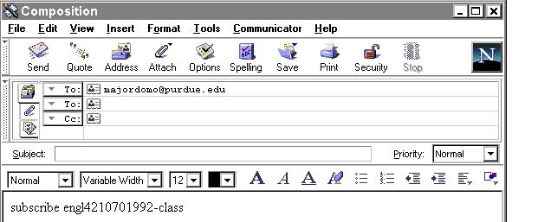
Address the message "To:" majordomo@purdue.edu

Leave the "Subject:" line blank.

In the message window, type:
subscribe engl4210701992-class

- Once you have completed the message as illustrated, click on the "Send" button along the Netscape Mail toolbar.

You likely will receive a "Netscape User Prompt" which points out that you have not included a "Subject:" line for your email message.

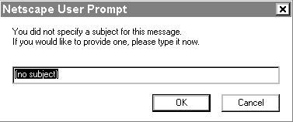
Click "OK."

- Do not add a "Subject:" line, and then, click on the "OK" button.
You will receive two messages from majordomo@purdue.edu:

- One of the messages will be a "Welcome to engl4210701992-class" message which
provides you with instructions for the mailing list.

- The other message will be a "Confirmation for subscribe engl4210701992-
class" message to which you must respond in order to be authenticated.

Sending your Authentication Message to Majordomo

In order to be fully subscribed to our class listserv, you must reply to the "Confirmation" message.

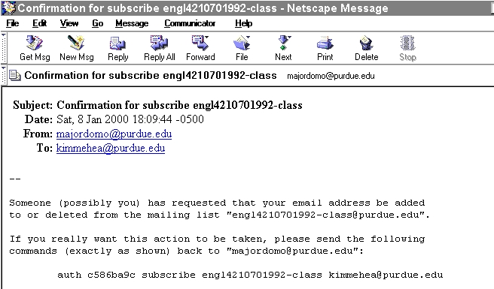
Highlight this line of your confirmation message.

- To respond easily to this authentication message, with your mouse, highlight the line that appears after the phrase, "If you really want this action taken, please send the following commands (exactly as shown) back to 'majordomo@purdue.edu':"

Note: The line will read something like, "auth c586ba9c subscribe engl4210701992-class kimmehea@purdue.edu".
- Once you have highlight the authentication line of the message, select Edit on the Netscape Mail menu bar.

- From the Edit pull down menu, select copy.

- Once you have selected copy, click on the "Reply" button on the Netscape Mail toolbar.

You will receive a message titled "Composition" which is automatically addressed to majordomo@purdue.edu.

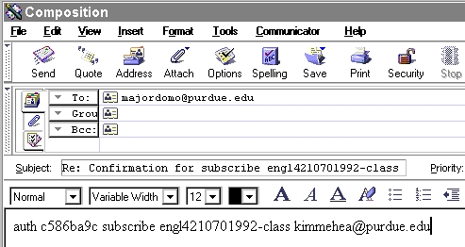
Paste your authentication line in the message window.

- Make sure your cursor appears in the message window above the text to which you are replying.

- Select Edit on the Netscape Mail menu bar.

- From the Edit pull down menu, select paste.

Your authentication action line will be pasted into the message window.

- With your mouse, highlight the rest of the text below your newly added authentication line.

- Select Edit on the Netscape Mail menu bar.

- From the Edit pull down menu, select cut.

- Make sure your authentication line remains and the rest of the message text is gone.

- Click on the "Send" button along the Netscape Mail toolbar.

You will receive two more messages from majordomo@purdue.edu:

- One of the messages will be a "Majordomo Results" message which explains that
you have "Succeeded" in subscribing to the listserv.
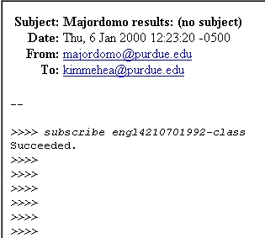

- The other message will be a "Welcome to engl4210701992-class" message which
provides you with instructions for the mailing list.

Testing your Class Listserv Set-up

To be certain that your subscription to the list is operable, you should send a test message to our class listserv.

- Click on the "New Msg" button along the Netscape Mail toolbar.

You will receive a new message screen entitled "Composition."

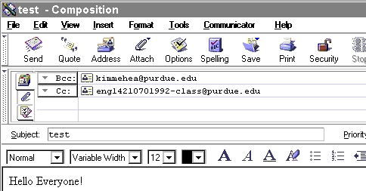
Address the message to engl4210701992-class@purdue.edu
Give the message the subject line of "test".
Compose a pleasant message to our class.
To:

- Address the message to "engl4210701992-class".

- Give it the "Subject:" line of "test".

- In the message window, compose a pleasant message to our class.

- Select the "Send" button along the Message toolbar.

You will receive your message in your own message Inbox as well messages from other class members.

Congratulations! You are successfully subscribed to our class listserv. Remember to check your email messages before each class meeting for updates and announcements.

